

Profiles
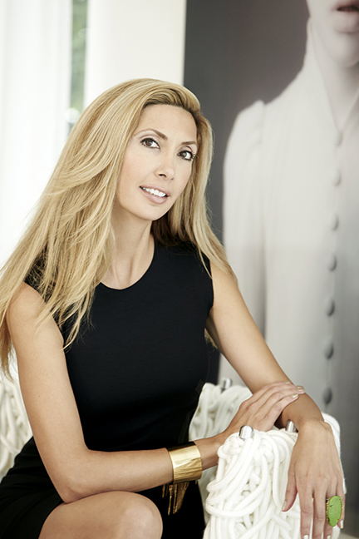
Rana Florida’s Creative Class
November 19
By Kate Betts
When Rana Florida was in college, she went backpacking through Europe with her sister and her cousin. She put aside money to spend on shopping in Paris. But when they arrived at the cheap youth hostel where they planned to stay in the French capital, Florida realized her money was better spent on the experience of a nice hotel. The intangible always outweighs the tangible, she says in her new book, “Upgrade: Taking Your Work And Life From Ordinary to Extraordinary.”
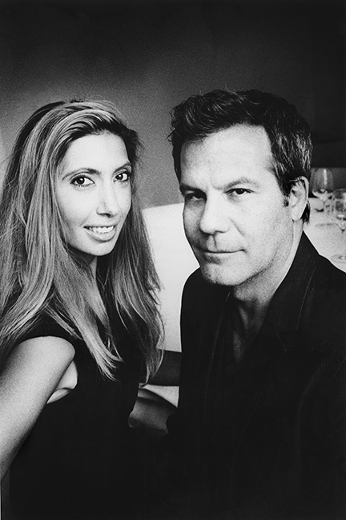
Rana and Richard Florida.

Florida, who runs The Creative Class Group with her husband, Richard, shows readers how we all have choices to make in our everyday lives, and how we can transform our experience by envisioning the future we want and going after it. It sounds like a familiar self-help trope, but you have to imagine a visual on Florida first, and then read her resumé. In addition to her consulting firm, she also contributes a column to The Huffington Post and is a regular contributor to HGTV. I felt like I knew Florida long before I met her through my brother, William. He constantly referred to her when doling out advice or recounting career success stories. “Rana says this” or “Rana does that,” he would tell me. When I finally met her, a stylish six-foot-tall blond with a brilliant smile and a mind to match, it made perfect sense that she would be publishing a book about how she had made the switch from a high-powered but dull corporate job at an advertising firm to running her own company with Richard, a renowned urban development expert.
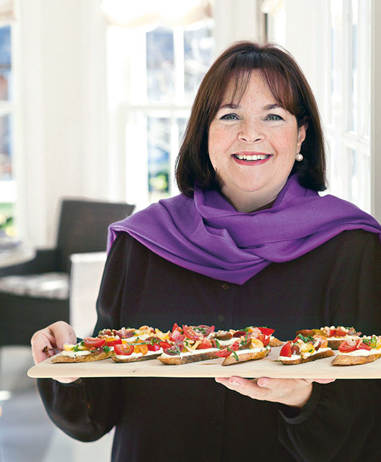
Ina Garten, one of the personalities Rana has interviewed for her book, “Upgrade: Taking Your Work And Life From Ordinary to Extraordinary.”
Through interviews with a fascinating group of people and anecdotes about her own career and life, Florida shows readers how to take risks and assess goals in order to improve everything about their lives—from leisure experiences to work habits to careers. Along the way, she illustrates her directives with anecdotes from creative leaders who reveal their secrets about switching careers or finding their passion or simply recognizing the most productive work habits and surroundings.
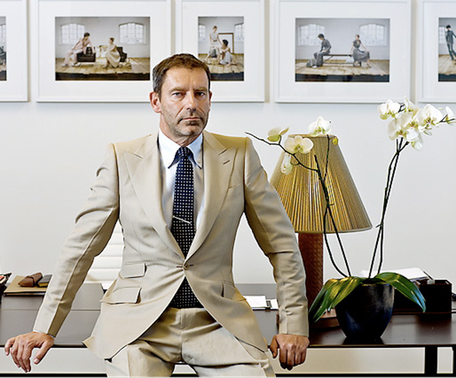
Tomas Maier talks about his creative process in Rana's book, "Upgrade".
Florida interviews people like popular chef Ina Garten about how she traded a dull career in international trade for a job running a specialty food shop in East Hampton, which lead to her bestselling cookbook and a career as an expert chef and television personality. Bottega Veneta designer Tomas Maier talks about his creative process and how he uses color to inspire him. Tim Brown, the CEO of design firm IDEO, describes how travel and changing contexts encourage new ideas. Florida has a gift in that she sees creativity in the smallest details—from coffee cups to website splash pages to the lining of a sneaker—and she reveals in her book how to do the same.
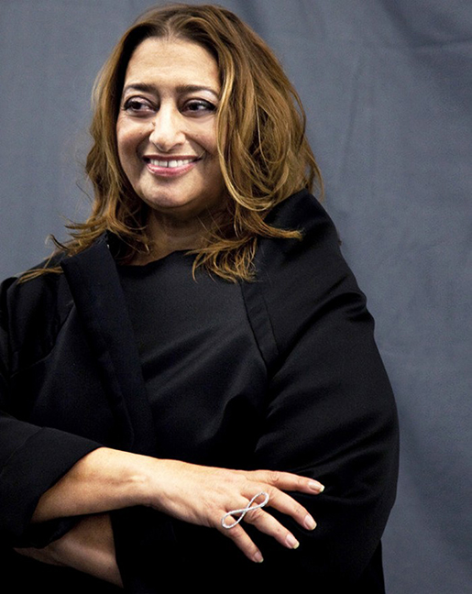
Rana reflects on her visit to Zaha Hadid's office in "Upgrade".
Additionally, she holds up familiar examples like Zappos CEO Tony Hsieh and his informal approach to breaking down the corporate walls between management and employees. Florida tells the story of visiting Hsieh and his team at their Las Vegas campus and how Hsieh insisted on hugging her hello instead of shaking hands. She also tours the offices of New York City’s Mayor Michael Bloomberg, Mayo Clinic president and CEO John H. Noseworthy and award-winning architect Zaha Hadid, taking the reader along for the ride and sprinkling the sage advice garnered from each trip throughout the book.
In all of her examples and axioms, the best guidance Florida offers is to stop wasting time. “It’s the most valuable resource we have,” she writes. “It’s the one thing we can’t buy, trade or get back.” That should be the starting point for all of us.

